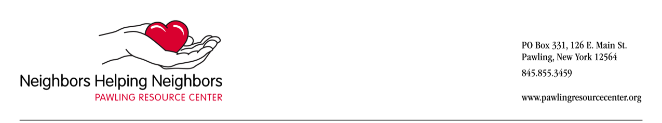**Pawling Resource Center 2023-2024**

**Transportation Client Intake Form**

Date: ________________________________

Name: ________________________________________________________________________

Address: ______________________________________________________________________

Phone number(s): _______________________________________________________________

Email address, if used: ___________________________________________________________

Date of birth: __________________________

Emergency contact name and phone: _______________________________________________

Use a walker or ambulatory device: _________________________________________________

Any special needs: ______________________________________________________________

**Defined by the New York State Office for the Aging (please check all that apply below):**

_____ Low income

_____ Low-income minority

_____ Live alone

_____White

_____ American Indian/Alaskan Native

_____ Asian

_____ Native Hawaiian/Pacific Islander

_____ Hispanic

_____ Black

_____Rural status

_____Frail or disabled

I understand the guidelines of the Pawling Resource Center program, and the following stipulations:

* This is a free service provided with volunteer drivers.
* The PRC makes every attempt to fulfill each request within these guidelines.
* If the PRC is unable to locate a driver for a particular request, it might not be filled.
* I understand that any requests outside of these guidelines may not be accepted by the PRC.

**Print Name of Transportation Client**

Signature _______ Date

**KEEP THIS PAGE FOR YOUR RECORDS:**

**GUIDELINES FOR REQUESTING TRANSPORTATION**

**to MEDICAL APPOINTMENTS**

**Who qualifies**? A client must reside in Pawling and meet low-income guidelines.

**Q: What is considered low-income?**  Households must meet the income criteria listed below:



**New clients** must fill out a Senior Transportation Client Intake Form and provide emergency contact information. We must ask for certain demographic information required by the Dutchess County Office of the Aging.

**Ride requests** will be accepted for appointments between 9 AM and 3 PM, Monday through Friday. In spring, summer & fall, this may be extended to 3:30 PM for local appointments. Registered clients can call the Resource Center and request a ride during open hours, Mondays - Fridays 10-4, and second Saturdays from 10 am -12 noon.

**Advance Notice:** Transportation requests must be given at least **14 BUSINESS DAYS** IN ADVANCE.

**Qualifying Rides:** Requests for transportation can be provided to **NON-EMERGENCY** medical appointments, including doctors, dentists, physical therapy, dialysis and medical tests (blood work, x-rays, MRI etc.) In addition, rides will be accepted for certain medical procedures that require sedation, like colonoscopy, **only if the client has a friend to accompany and/or if driver is amenable**.

**The Pawling Resource Center is not an emergency service.** If you need immediate assistance and have an emergency, call 9-1-1. We do not accept MD’s requests to drive patients to an Emergency Room.

**Client must be able** to walk independently or with walker. We cannot accept wheelchair bound clients, as we are unable to transport wheelchairs. Clients with portable oxygen units can be transported only at discretion of driver.

**There is no fee** for services provided, although we do accept tax deductible donations.

**WE DO NOT DRIVE IN INCLEMENT WEATHER. IF THE SCHOOLS ARE CLOSED, WE WILL NOT PROVIDE RIDES.**

**Volunteers cannot provide hands on care**, such as personal grooming, assisting with dressing, transferring to chairs, etc. Our drivers are not qualified and cannot administer medication. We do not provide housekeeping services or do outdoor chores – shoveling snow, etc.

**Medicaid recipients** have free non-emergency medical transportation provided to them through Medicaid. The PRC has a list of local providers.

If a client has a grievance, they can call write their concern and send it to the PRC. Envelopes are in car; or call the PRC during business hours and speak with the Director.

**The program is supported by Dutchess County Office of the Aging,**

**and United Way of Dutchess-Orange Region.**

